The Lord’s Prayer

Our Father, who art in heaven, hallowed be thy name. Thy kingdom come, Thy will be done on earth as it is in heaven. Give us this day our daily bread and forgive us our trespasses, as we forgive those who trespass against us. And lead us not into temptation, but deliver us from evil. For thine is the kingdom, and the power, and the glory, forever. Amen.
*Singing Our Faith # 467 “Trust and Obey”
*Blessing and Dismissal
*Postlude
Scatter to Serve God & Neighbor

Welcome to all! We gather to praise God for the innumerable blessings given to us and to grow deeper in the Spirit. Joyfully, let us lift our hearts to God.

DIRECTORY OF CHESTNUT HILL UNITED METHODIST CHURCH
Sue Haupert-Johnson |  | Richmond Area Resident Bishop
 | Denise Bates |  | Mountain View District Superintendent
 | Adam White |  | Minister
 | Erin Long |  | Associate Minister
 | Monica Campbell |  | Administrative Assistant
 | Heather Wilson |  | Director of Music Ministry
 | Judy Martin |  | Bookkeeper
 | Judy Robertson  Elizabeth Nichols |  | Lay Leader  Missionary in Henry County

C hestnut Hill
United Methodist Church

Making disciples of Jesus Christ
for the transformation of the world.
You are welcome at Chestnut Hill UMC.

4660 Fort Avenue ~ Lynchburg, Virginia 24502
Church: 434-239-8423
Minister’s Cell: 434-944-7723, Minister’s Email: awhite@ves.org
Associate Minister’s Cell: 1-502-489-0200
Associate Minister’s Email: healingsolutions12@gmail.com
Email: chestnuthillumc@comcast.net
On the Web at chestnuthillumc.net
Find us on Facebook: Chestnut Hill United Methodist Church

Chestnut Hill United Methodist Church
10:30 a.m. ~ February 18, 2024 ~First Sunday in Lent
Our ministry vision for the Virginia Annual Conference is “to be disciples of Jesus Christ who are lifelong learners, who influence others to serve.”

Welcome! Join us in worshiping God!

Prelude
Welcome and Ministry Announcements
Welcome in the name of Christ our Lord. Please register your attendance, printing your name, address, phone, and email, on the attendance pad provided on your pew. Thank you for silencing cell phones as we gather to worship God.
Invocation
*Greeting
Dear Lord and Father of mankind,
Forgive our foolish ways!
Re-clothe us in our rightful mind,
In purer lives Thy service find,
In deeper reverence, praise.
In simple trust like theirs who heard,
Beside the Syrian sea,
The gracious calling of the Lord,
Let us, like them, without a word
Rise up and follow Thee.
Drop Thy still dews of quietness,
Till all our strivings cease;
Take from our souls the strain and stress,
And let our ordered lives confess
The beauty of Thy peace. (John Greenleaf Whittier, 1872)
*Singing Our Faith # 701 “When We All Get to Heaven”

Opening Prayer
Almighty God, whose blessed Son was led by the Spirit to be tempted by Satan: Come quickly to help us who are assaulted by many temptations; and, as you know the weaknesses of each of us, let each one find you mighty to save; through Jesus Christ your Son our Lord, who lives and reigns with you and the Holy Spirit, one God, now and for ever. Amen.

Anthem “Love Divine, All Loves Excelling”

Greeting Friends and Neighbors
Prayer for Illumination
Gracious God, we do not live by bread alone. Let the heavenly food of the scripture we are about to hear nourish us today in the ways of eternal life, through Jesus Christ, the bread of heaven. Amen.
Scripture Lesson Mark 1:9-15
The Word of God for the people of God.

Thanks be to God.
Singing Our Faith # 337 “Only Trust Him”
The Good News
“Initiation, Temptation, Contemplation, Proclamation, Celebration and Expectation are the State of the Situation”

Bringing Forward God’s Tithes and Our Gifts
*Doxology # 95 Praise God from whom all blessings flow; praise him, all Creatures here below; praise him above, ye heavenly host; praise Father, Son, and Holy Ghost. Amen.
*Prayer of Thanksgiving
Sharing of Joys and Concerns

**Calendar **
Monday, 2/19 |  | President’s Day  Church Office Closed
Thursday, 2/22 | 10:30 a.m. | Merry Martha’s Circle  Lenten program. Lunch out.
 | 11:00 a.m. | Homeschool meeting
Friday, 2/23 | 10:00 a.m. | Homeschool
Saturday, 2/24 | 1:00 p.m. | Baby Shower

Hospital:

Lynchburg General: Claude “Donnie” Childress

For the Grocery Cart: February
Pop-top cans of meats, soups, pasta dishes, vegetables, and body wash. Place donations in the grocery cart, located in the Commons.

Souper Bowl of Caring~Meals on Wheels

For donations use a pew envelope and make checks payable to “Chestnut Hill UMC” and mark it for “Meals on Wheels”.

Cards for Homebound Members

Please take a moment to sign the cards for our homebound members/friends that Erin has placed in the Commons.

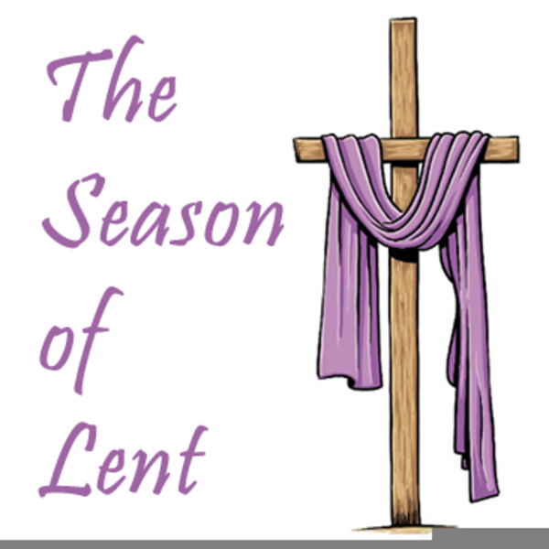

**Calendar **
Monday, 2/19 |  | President’s Day  Church Office Closed
Thursday, 2/22 | 10:30 a.m. | Merry Martha’s Circle  Lenten program. Lunch out.
 | 11:00 a.m. | Homeschool meeting
Friday, 2/23 | 10:00 a.m. | Homeschool
Saturday, 2/24 | 1:00 p.m. | Baby Shower

Hospital:

Lynchburg General: Claude “Donnie” Childress

For the Grocery Cart: February
Pop-top cans of meats, soups, pasta dishes, vegetables, and body wash. Place donations in the grocery cart, located in the Commons.

Souper Bowl of Caring~Meals on Wheels

For donations use a pew envelope and make checks payable to “Chestnut Hill UMC” and mark it for “Meals on Wheels”.

Cards for Homebound Members

Please take a moment to sign the cards for our homebound members/friends that Erin has placed in the Commons.

